The visit of a Syrian (Assyrian) Priest to Australia: news accounts and official documents

This article based on news accounts and official Australian documents will show the strict conditions imposed on Anglican Minister, Rev Malek Ormuz regarding his entry into Australia. His visit to Australia received extensive coverage in the Australian and to a lesser extent in New Zealand, Singapore and United States newspapers in mid-June 1922. The main focus of this paper will be the use of Australian sources. Australia did not have an official Department of Immigration operating in 1922, as all immigration issues were handled by the Home and Territories Department in Melbourne. The Collector of Customs at each Australian port was responsible in implementing Australia’s Restrictive immigration laws. From 1901-1945 Australia preferred British rather than non-British immigrants.

Rev. Melik Ormuz was supposed to lecture on the sufferings of the Syrians in Mesopotamia to the Australian community. It is interesting to note that the Melbourne Herald, Melbourne Argus, Sydney Morning Herald Sydney Sun,and Hobart Mercury newspapers described Ormuz as a Chaldean Priest. The Sydney Morning Herald article of June 13, 1922 states that “… customs authorities have reason to believe that he (Ormuz) is on a mission collecting mission for his countrymen.” On June 9 the Collector of Customs, New South Wales (NSW), W.M Barkley informed the Secretary, Home and Territories Department in Melbourne that Assyrians in Sydney had found out from Ormuz “that he has come on a begging mission to Australia.” Ormuz traveled under a British passport issued in Chicago which was endorsed allowing him to travel to Australia, New Zealand and Africa. When questioned by Australian customs, Ormuz told them that he only had $50 on him. Furthermore, he claimed that he possessed a letter of introduction to the Bishop of the Church of England in Sydney. He failed to produce the letter and "stated he meant he was going to call the Bishop." The Collector of Customs of Customs, NSW telegraphed the Home and Territories Department that Ormuz had informed "local Church England Clergyman Tomlinson Seamans" regarding the purpose of his trip to Australia. However there are omissions on the digital copy of this telegram.
Ormuz stated he had insufficient funds to book a passage and requested that he be permitted to cable his sister in Chicago so that she could send him the money. He was confined to the SS Ventura awaiting the arrival of funds from his sister. Once the money arrived, he would pay for his passage to Colombo. He departed on board the SS Ventura for San Francisco from Sydney on June 14.

On July 3, 1922 the Official Secretary of the Governor-General, J.H Starling wrote to the British Passport Control Officer in New York regarding the Ormuz case. He stated:

Melik Ormuz alleged Assyrian clergyman holder passport issued by British Consul, Chicago arrived Sydney per Ventura 6th June for purpose collecting funds. He was rejected and is returning home by same vessel. Owing to previous impostures so-called Armenian, Assyrian or Chaldean missionaries who come Australia for collecting purpose are not permitted land and should not given passport facilities.

The collected funds were supposedly to be used "for the purpose of erecting orphanages, or relieving distressed refugees from the Turks." The British Ambassador in Washington, Sir Auckland C.Geddes told the Governor-General that all British Consular officials in the USA had been instructed accordingly to deny passport facilities to these bogus collectors.

The Singleton Argus, stated that Syrians were regarded as Asiatics under the Immigration Restriction Act. Ormuz could have applied for an exemption under three categories: as a tourist, student and merchant but did not fit any of these classes. A £100 deposit was put up as a guarantee to ensure that he would depart on the next ship from Australia. There are Australian press reports which mention Ormuz being accompanied by Customs officers to do some shopping in Sydney. There are no details either in the press or official sources who actually paid the £100 bond, one can assume that his sister wired him sufficient funds to cover the guarantee and his return passage to America.

According to the Australian press, Ormuz described his refused entry as a "UnChristian Ban' and was "treated like a black man." He stated that he would challenge this decision with the Foreign Office in London. Prior to his departure, he was interviewed by a correspondent of the Sydney Sun where the journalist pointed out that the public should be informed of the suffering of his people. At the start, Ormuz was reluctant to speak and halfway through the interview "let me see those notes", he said. He grabbed them from the journalist and tore them into small pieces. However "then he preached a sermon to the reporter on the ethics of Christianity and the way to salvation and dismissed him with a blessing." Another journalist attempted to interview him but slammed the cabin door in his face. His angry outbursts towards journalists can be explained in terms of being refused entry into Australia. The unfortunate Sun reporter was merely seeking to gather information on the plight of Syrians to inform his readership.

There are two further points that emerge from the news articles. First for e.g. New York Times and Sydney Morning Herald report that Ormuz was an “Anglican Minister to the Syrian community in Chicago.” whereas Western Argus, The Register and Mercury describe him as a "Church of England [Minister]." There is no dispute regarding Ormuz residency in Chicago but the Anglican Church is not known by that name in the United States. It would have been correct to have referred it as the Episcopalian Church. The Archbishop of Canterbury sent a mission to the Assyrians in 1886. This mission became the focal point for the training of priests and printing religious books.

In the second case, for e.g. the Argus and Sydney Morning Herald articles on June 14, 1922 describe Ormuz as a Chaldean. The term Chaldean refers to a religious domination rather than an ethnic or racial group as Chaldeans belong to the Roman Catholic Church.
According to a document titled The Claims of the Assyrians before the Conference of the preliminaries of peace at Paris it divides the Assyrians into their three chief religious denominations. These include “(A) The Nestorians have predominated in the Kurdish mountains, inhabiting Barwar, Tyari, Tkhooma, Baz, Jeloo, Gavar etc with Koodchanis as their patriarchal see. (B) The Chaldeans predominate in the province of Mosul, abounding also in the various locations in lower Messopotamia down to the Persian gulf, with Mosul as their patriarchal see. (C) The Jacobites prevail in the province of dearbeker, abounding also in Syria proper, and in other localities in the former of Turkey, with the city of Mardin as their patriarchal see.” Lt-Colonel RS Stafford, a British official, who worked in the Iraqi administration from 1927-1933 describes the Assyrians as a racial group and also outlines their religious differences.

In conclusion, Australian authorities refused Ormuz entry into Australia because his real mission was to beg or solicit funds under the pretense of helping his compatriots in Mesopotamia. The Australian newspaper accounts highlight his dissatisfaction with the treatment he received from Australian officials with the term " treated like a black man."

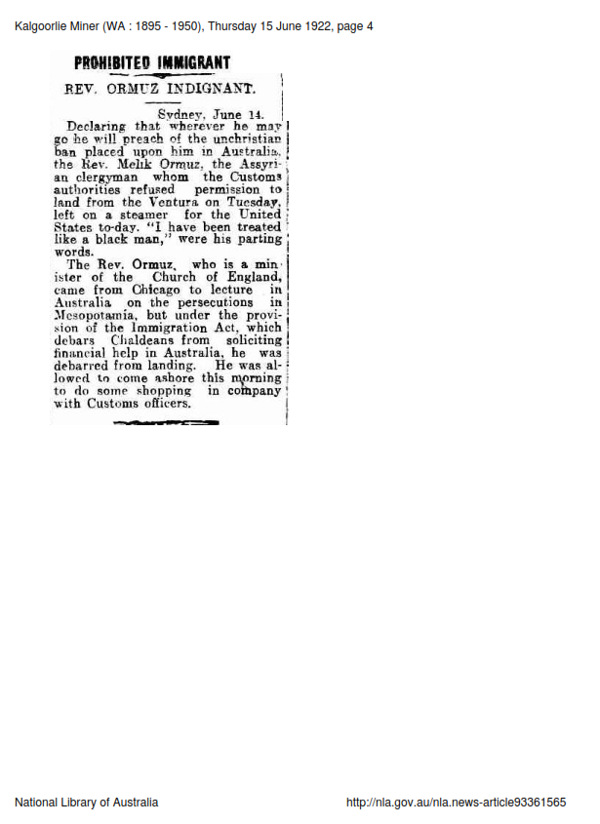

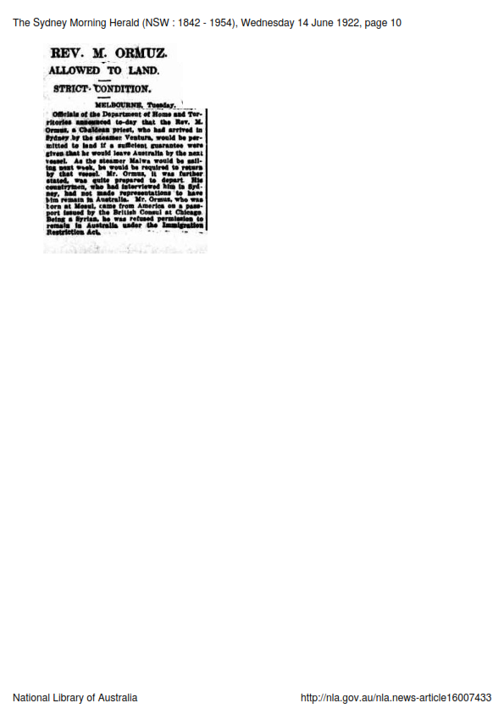

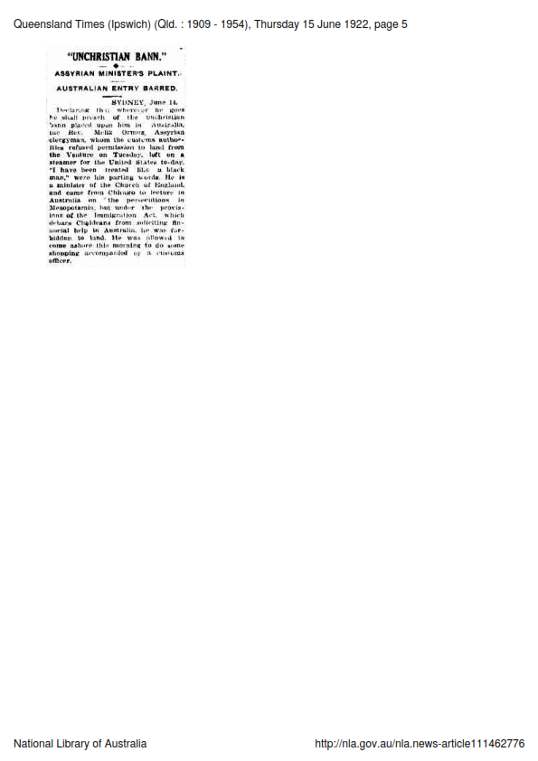

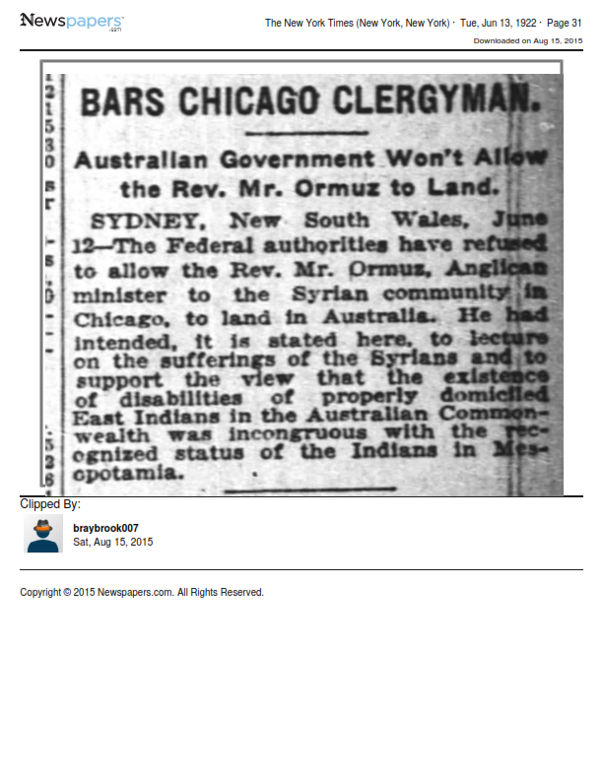

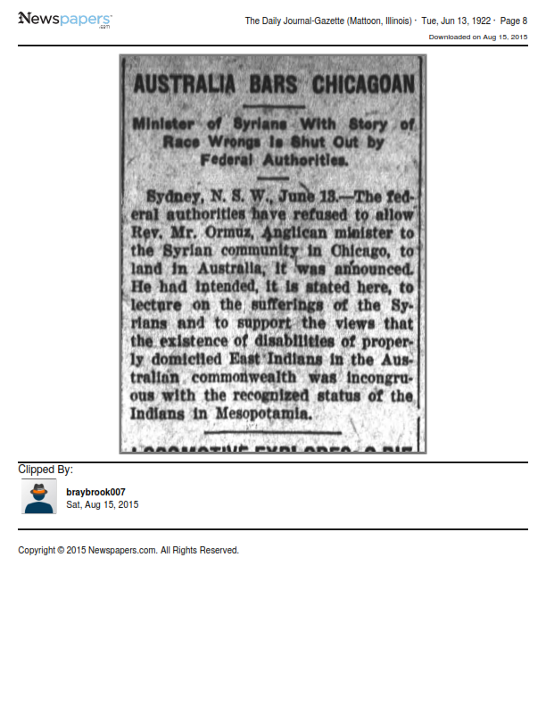

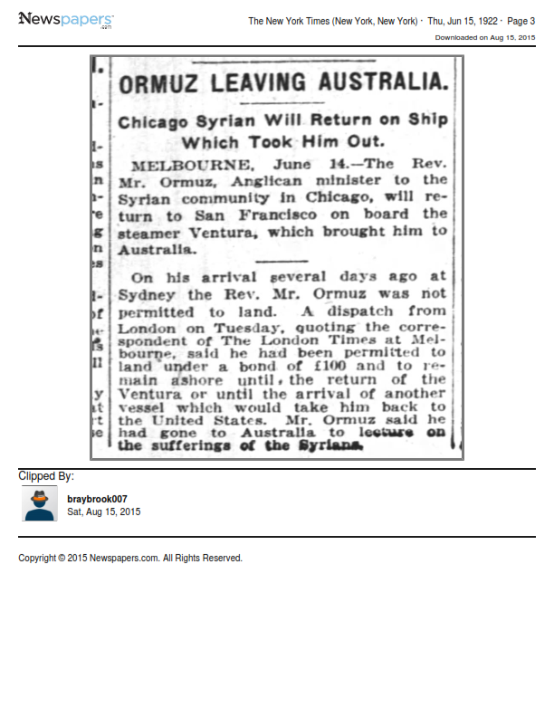

The international press coverage on Rev Ormuz, see 'Australia Excludes', Straits Times, (Singapore) June 14, 1922, p.9 & 'The Rev Ormuz', June 15, 1922, p.7; 'Agitators not wanted', ( Singapore) Singapore Free Press and Mercantile Advertiser, (Singapore), June 14, 1922, p.7& 'Commonwealth Bars Ormuz', June 16, 1922, p.7; 'Lecture tour halted, Rev, Mr Ormuz to leave Australia for the United States at once', Evening Star, (Washington DC), June 15, 1922, p.42; 'Clergyman can't enter Australia', Seattle Star, June 14, 1922, p.10; 'Bars Chicago Clergyman', New York Times, June 31, 1922, p.31; & 'Syrian allowed to land', June 14, 1922, p.6 & 'Ormuz leaving Australia', June 15, 1922, p.3; 'Assyrian Cleric's Mission. Not allowed to land', Auckland Star (New Zealand). June 13, 1922 , p.5; 'Landing Forbidden', Evening Post (New Zealand), June 13, 1922, p.7; 'The Excluded Assyrian', New Zealand Herald, June 15, 1922, p.7 & 'Assyrian Cleric Departing', June 16, 1922, p.7
National Archives of Australia (NAA), Canberra (ACT) Series A8 item 1902/49 pt.2 , Commonwealth of Australia Gazette, No.1 3rd January 1902: Immigration Restriction ACT 1901; For a discussion of British and non-British migration to Australia, see Eric Richards, Destination Australia, UNSW Press, Sydney, 2008; Michael Roe, Australia, Britain and Migration, 1915-40, Cambridge University Press, Cambridge, 1995; James Homs &W.H Morris-Jones, Australia and Britain, Routledge, 2005; Brian Murphy, The Other Australia: Experiences of Migration, Ethnic Affairs Commission of NSW, Sydney, 1993; James Jupp, From White Australia to Woomera, 2nd ed, Cambridge University Press, Melbourne, 2007
'Chaldean Priest must leave', Argus, June 14, 1922, p.12; ;'The Chaldean's Reticence. Prohibited Clergyman refuses interview', Herald, June 14, 1922; 'The Chaldean Priest, Refused Permission to land', Mercury, June 15, 1922, p.12; 'Rev M.Ormuz.Allowed to land strict conditions', Sydney Morning Herald, June 14, 1922, p.10; 'Chaldean's Sermon "Treated like a Black". Aversion to Interviews", Sun (Sydney), June 14, 1922
'Not allowed to land. Syrians and Italians', Sydney Morning Herald, June 13, 1922, p.10
NAA Series A1 item1922/17894 The Collector of Customs, NSW to Secretary, Home and Territories Department, Melbourne June 9, 1922
NAA Series A1 item1922/17894 The Collector of Customs, NSW to Secretary, Home and Territories Department, Melbourne June 9, 1922; Barkley, Sydney tel.to Secretary Home Territories, Melbourne, June 9, 1922
NAA Series A1 item1922/17894 The Collector of Customs, NSW to Secretary, Home and Territories Department, Melbourne June 9, 1922; Sydney tel. to Secretary Home Territories, Melbourne, June 13, 1922
NAA Series A1 item1922/17894, JH Starling, Official Sec of H.E Governor-General to The British Passport Control Office, New York July 3, 1922; AC Geddes, British Embassy, Washingto DC to Governor-General, Government House, Melbourne, August 14, 1922
'The Detained Assyrian. Authorities' explanation', Singleton Argus, June 15, 1922, p.4; NAA Series A1 item1922/17894, Barkley, Collector Custom, Sydney, June 9, 1922
'Treated like a Black Man. Assyrian Clergyman leaves Sydney.', Examiner, June 15, 1922, p.4; 'A banned Syrian. Will preach abroad against Australia', The Register, June 15, 1922, p.8; 'Rev M.Ormuz. Allowed to land strict condition', Sydney Morning Herald, June 14, 1922, p.10
"UnChristian Bann" Assyrian Ministers' Plaint. Australia entry barred', Queensland Times, June 15, 1922, p.5; 'Clergyman's Protest. A "UnChristian Ban', West Australian, June 15, 1922, p.8; 'The Forbidden City. Rev Ormuz leaves. Will take action', Evening News, June 14, 1922, p.7
; 'Chaldean's Sermon "Treated like a Black". Aversion to Interviews", Sun (Sydney), June 14, 1922; It would be interesting to see if Ormuz did actually take action against the British Foreign Office in London.
; 'Clergyman can't enter Australia', Seattle Star, June 14, 1922, p.10; 'Bars Chicago Clergyman', New York Times, June 31, 1922, p.31; & 'Syrian allowed to land', June 14, 1922, p.6 & 'Ormuz leaving Australia', June 15, 1922, p.3; 'Not allowed to land. Syrians and Italians', Sydney Morning Herald, June 13, 1922, p.10; Western Argus, June 20, 1922, p.5; The Register, June 15, 1922, p.8; The Mercury, June 15, 1922, p.12
Lt Col RS Stafford, The Tragedy of the Assyrians, 1935 which is available at books online www.aina.og
The Claims of the Assyrians before the Conference of the preliminaries of peace at Paris
See ch.1 in Lt Col RS Stafford, The Tragedy of the Assyrians, 1935 which is available at books online www.aina.og

